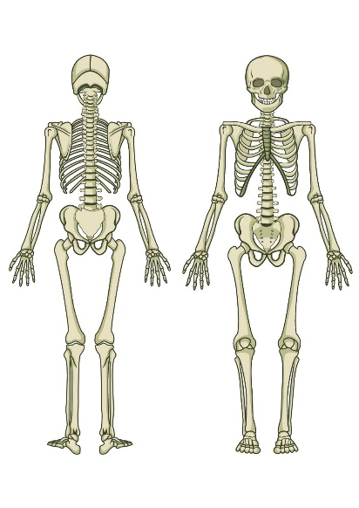



**PRE CAM TECH COURSE**

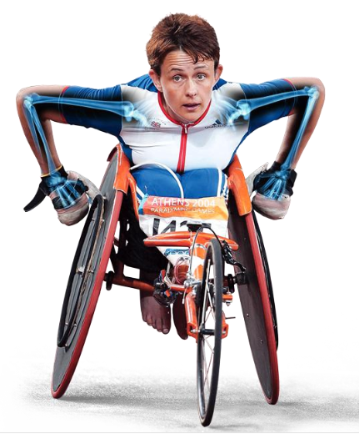**IN SPORT**

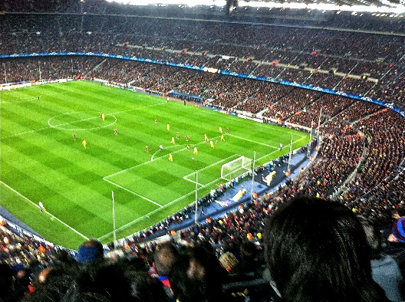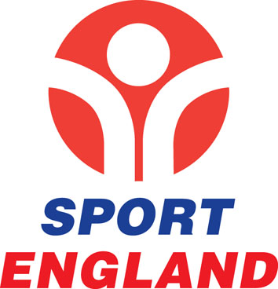

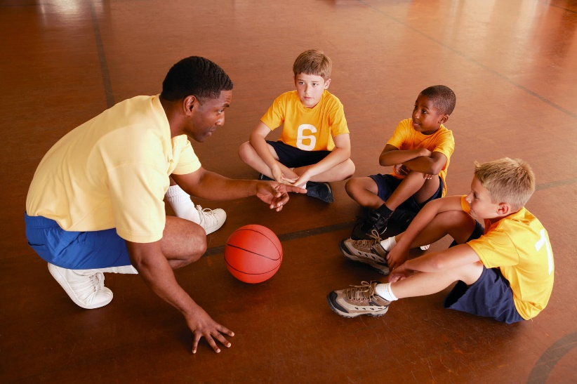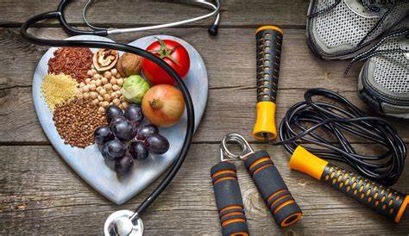

**CAM TECH SPORT COURSE OUTLINE**

|  |
| --- |
| The course specification and units can be accessed here (**OCR Specification**):  This course is called the Cambridge Technical Extended certificate in Sport. It is the equivalent to 1 A level and is graded with a pass, merit, distinction or distinction* as an overall grade at the end of Year 13.  The course is split into 6 units. 2 units will be assessed with an external exam and 4 units will be assessed with coursework.  These are the units you will study over Year 12 and 13:  **Year 12**  Unit 1 - Body systems and the effects of physical activity (external exam in January)  Unit 2 – Sports coaching and activity leadership (coursework)  Unit 12 – Nutrition and diet for sport and exercise (coursework)  **Year 13**  Unit 3 – Sports organisation and development (external exam in January)  Unit 8 – Organisation of sports events (coursework)  Unit 11 – Physical activity for specific groups (coursework) |

**SUMMER TRANSITION WORK**

We are so excited to hear that you are hopefully going to be joining us in September to study Cam Tech Sport.

This booklet will give you a brief introduction to the course layout and help you to start getting to grips with some of the key terminology and content so that we can hit the ground running in September.

**The first term** there are 2 units we will study. One unit will result in an external exam in January. One unit will include planning and preparing for coaching/leading sports sessions in the Summer term.

Please complete the 3 tasks below and bring this completed workbook with you in September. We have also added some links and information about future Career Pathways in Sport, with links for you to do some research!

**Best wishes, Team Sport**

**TASK 1: BODY SYSTEMS**

You will learn about the muscles and bones during the first half term of the A Level PE course. The list of bones and muscles you need to know are listed below.

|  |  |
| --- | --- |
| **BONES** | **MUSCLES** |
| cranium | **Shoulder**: deltoid, latissimus dorsi, pectoralis major, trapezius, teres major |
| sternum | **Elbow** – biceps brachii, triceps brachii |
| ribs | **Radio-ulnar** – supinator muscle, pronator teres |
| vertebral column | **Wrist** – wrist flexors, wrist extensors |
| scapula | **Vertebral column** – rectus abdominus, erector spinae group, internal and external obliques |
| clavicle | **Hip** – iliopsoas, gluteus maximus, gluteus medius, gluteus minimus, adductor longus, adductor brevis, adductor magnus |
| humerus | **Knee** – rectus femoris, vastus medialis, vastus intermedius, vastuc lateralis, biceps femoris, semimembranosus, semitendinosus |
| radius | **Ankle** – tibialis anterior, gastrocnemius, soleus |
| ulna |  |
| carpals |  |
| metacarpals |  |
| phalanges |  |
| ilium |  |
| ischium |  |
| pubis |  |
| femur |  |
| patella |  |
| tibia |  |
| fibula |  |
| tarsals |  |
| metatarsals |  |
|  |  |

Here is a blank picture to help you to practice learning the bones You may wish to print this page out a number of times and practice labelling it to test how many muscles you can remember. Once confident with your knowledge of the muscles, complete a final one below and bring it to the lesson during the skeletal system topic.

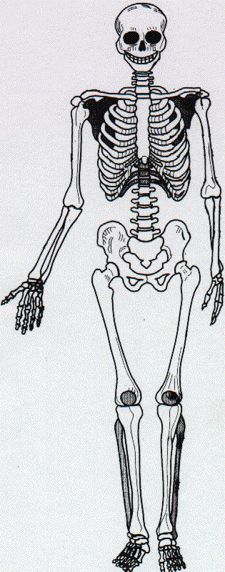

Here is a blank picture to help you to practice learning the muscles. You may wish to print this page out a number of times and practice labelling it to test how many muscles you can remember. Once confident with your knowledge of the muscles, complete a final one below and bring it to the lesson during the muscular system topic.

**TASK 2 – SPORTS NUTRITION**

**Fact Finding research task**

**Write your answers in the spaces provided:**

1. Which UK organisation has created the Eatwell guide?
2. Which nutrient provide energy for the body?
3. What is the average calorie recommendation for men and women?
4. Give 3 effects of dehydration.
5. Names the different types of sports drinks.
6. Which supplements provides more protein for sports people?
7. What is the thermic effect in nutrition?
8. What is the 5:2 diet? Give a brief description

**TASK 3 – SPORT COACHING AND LEADERSHIP**

**Read the extract below**

The different leadership styles used by sports coaches and leaders are:

* Autocratic Leadership
* Democratic Leadership
* Laissez-Faire Leadership

It should be noted that all leadership styles are adjustable and will be dependent on several factors. From our experience in sports coaching, leaders can [change their leadership styles to suit the situation coaches find themselves in.](https://www.leadershipandsport.com/stages-of-learning/) Rarely have we used the Laissez-Faire approach. However, we have both used the Democratic and Autocratic Leadership styles when needed.

In the research by Lewin, Llippet & White (1939) it is decided that the best leadership style was the democratic leadership style. Too much autocratic leadership can lead to athletes and players deciding that they no longer wish to work with a coach and may begin to refuse to follow instructions. Whereas, a Laissez-faire leader can potentially lead to teams not performing as they may become disorganised. This can have an effect of reducing a [players’ motivation and determination](https://www.leadershipandsport.com/intrinsic-and-extrinsic-motivation-what-is-it/).

**The Autocratic Leadership Style**

The autocratic leadership style is seen as a leader who makes a decision and decides that is what is being done. Autocratic leadership does not take into account other people’s views or decisions and has the “this is what is happening” attitude.

Many professional coaches have shown this leadership style of the years with Alex Ferguson an example of this. Arguably one of the most successful sports managers, he gained fame for showing this leadership style during his career.

### ****The Democratic Leadership Style****

The democratic leadership style is when a leader determines what is needed to be done, explains this, seeks feedback from the team/players and then decides how to proceed.

Jurgen Kloop has shown on several of occasions the ability to use the democratic leadership style to a successful effect (some may argue otherwise). The ability to seek feedback from players can increase motivation and [the “feel valued” aspect which in turn my increase motivation and improve performance.](https://www.leadershipandsport.com/intrinsic-and-extrinsic-motivation-what-is-it/)

### ****The Laissez-Faire Leadership Style****

The Laissez-Faire Leadership Style is when a leader does not take an active approach. A laissez-faire leader may decide what needs to be done but will then seek advice from players/athletes and then enable athletes to make the decision.

This approach can often lead to teams making a poor decision based on personal preference and can impact directly only performance and progress. We have seen examples of teams talking over a coach when they are speaking to the team. This approach can be seen as a leader not demonstrating leadership and can easily lead to teams moving from the direction a coach has set out from the start.

### ****How Can Understanding Leadership Styles Benefit You?****

We recommend all sports coaches and leaders to understand their leadership traits. [Leadership is about being able to get others to trust you, lead change and deciding the next steps](https://www.leadershipandsport.com/improving-your-sports-coaching/). Therefore, by understanding the different leadership styles, you should be able to understand how you are leading and the impacts of this.

As a sports coach/leader, understanding your teams personality types and the different leadership styles can have a major impact on team performance and athlete development. When observing other coaches,[try to determine what traits they are using and their leadership style](https://www.leadershipandsport.com/improving-your-sports-coaching/). Each sports coach will have their leadership traits. However, this does not necessarily mean they will always use the same leadership styles. This is all dependent on the situation a coach finds themselves in.

Answer the following questions below:

1. According to the extract which leadership styles is best for a coach/leader? Explain why.
2. Can you think of situations where different leadership styles can be used by the same coach in different situation? Eg with a new team, where safety is important.
3. Give examples of leadership styles you have experienced from sports coaches or even your own PE teachers.

**KEY WORDS IN CAMBRIDGE TECHNICAL IN SPORT**

Understanding the command words for different assignments is vitally important for success. Below are a selection of keyword words that are used in assignments and exam questions.

|  |  |
| --- | --- |
| **Demonstrate** | Show in an explicit way (often practically demonstrate). |
| **Describe** | Give an account, including all the relevant characteristics, qualities or events.   |  | | --- | |  | |
| **Explain** | To give account of the purposes or reasons |
| **Outline** | A description setting out main characteristics/points. |
| **Plan** | Consider, set out and communicate what is done. |
| **Justify** | Present a reasoned case for actions or decisions made. |
| **Evaluate** | Make a qualitative judgement taking into account different factors and using different knowledge/experience/evidence. |
| **Compare** | Identify similarities and differences. |
| **Assess** | Offer a reasoned judgement of the standard/quality of situation/skills informed by relevant facts. |
| **Review** | Survey information, methods, outcomes, conclusions after the event, deciding what was effective or not. |
| **Analyse** | Separate into components and identify their characteristics. Discuss the pros and cons of a topic or argument and make reasoned comment. |

**ASSIGNMENT WRITING TIPS**

* Make notes during the assignment introduction lesson.
* Make notes on the content of the assignment and the assessment criteria.
* Research the topic of the assignment using a variety of websites and read any relevant articles. You can make further notes here.
* Email/speak to your teacher if you need further help.
* Before handing your assignment in read it through carefully checking that you have included everything on the assignment sheet.
* Don’t forget to include a bibliography.
* Hand you assignment in on time. Email your teacher 24 hours before the set deadline if you need an extension.
* Respond to feedback given to your teacher and make amendments/improvements to your coursework by the next set deadline.

**USEFUL WEBSITES**

**UNIT 1 – Body systems & the effects of physical activity**

<https://medlineplus.gov/anatomy.html>

<https://www.innerbody.com/htm/body.html>

<https://www.livescience.com/37009-human-body.html>

**UNIT 2 – Sports coaching & leadership**

<https://www.brianmac.co.uk/coachsr.htm>

<https://www.ukcoaching.org/resources/topics/videos/how-to-plan-and-organise-a-coaching-session>

<https://athleteassessments.com/stages-of-team-development-in-sport/>

**UNIT 3 – Sports Organisation & development**

<https://www.sportengland.org/>

<https://www.uksport.gov.uk/>

<https://network.streetgames.org/our-work-changing-sport/national-governing-bodies>

**UNIT 8 –Organisation of sports events**

<https://www.ticketsource.co.uk/blog/how-to-plan-a-sport-event>

[https://prezi.com/pjaq9oofhev8/roles-and-responsibilities-of-four-individuals-involved-in-sports-events/https://prezi.com/pjaq9oofhev8/roles-and-responsibilities-of-four-individuals-involved-in-sports-events/](https://prezi.com/pjaq9oofhev8/roles-and-responsibilities-of-four-individuals-involved-in-sports-events/)

**UNIT 11 – Physical activity for specific groups**

<https://www.healthline.com/nutrition/10-benefits-of-exercise#section3>

<https://lucyysullivann.wordpress.com/2015/03/11/the-sport-continuum-for-different-target-groups/>

<https://www.nice.org.uk/guidance/ph54/documents/exercise-referral-schemes-draft-guideline2>

**UNIT 12 – Sports nutrition**

<https://www.nhs.uk/live-well/eat-well/>

<https://hydralytesports.com.au/importance-of-hydration/>

<https://www.mealplansite.com/>

**CAREER PATHWAYS IN SPORT**

University Pathway:

**TOP SPORTING UNIVERSITIES**

Loughborough University: [Courses | School of Sport, Exercise and Health Sciences | Loughborough University (lboro.ac.uk)](https://www.lboro.ac.uk/schools/sport-exercise-health-sciences/undergraduate/courses/)

Bath University: [Sport courses (bath.ac.uk)](https://www.bath.ac.uk/corporate-information/sport-courses/)

Exeter : [University of Exeter | Sport courses | UCAS](https://www.ucas.com/explore/related/91fd2fa0-e5ec-efe7-eb46-db8f10a74059?subject=Sport&studyYear=current&studyLevel=undergraduate)

**SPECIALIST FOOTBALL**: [UCFB | GIS University Degrees in the Football and Sports Industry](https://www.ucfb.ac.uk/)

**LOCAL AREA**

Bournemouth University: [Bournemouth University | Sport courses | UCAS](https://www.ucas.com/explore/related/22e93c90-ca5f-983e-8c2a-f215d4e544d3?subject=Sport&studyYear=2022&studyLevel=Undergraduate)

AECC University College: [Sport, Exercise and Health Science degree courses | AECC University College Bournemouth | AECC University College | Transforming lives through Health Sciences](https://www.aecc.ac.uk/study/our-courses/undergraduate-courses/sport-exercise-and-health-science/)

**CAREER PATHWAY POSTERS (University routes)**

**Apprenticeship Routes**

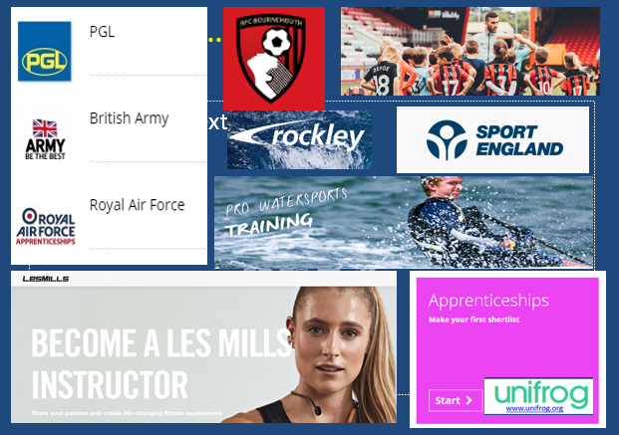Apprenticeships typically consist of 80% on-the-job training, and 20% studying. For some opportunities this means 4 days per week at the workplace and 1 day at a college, and for others this means you will work for about 10 months a year, then you'll spend 2 months just studying. [Sport and fitness apprenticeships | The Apprenticeship Guide](https://apprenticeshipguide.co.uk/apprenticeship-category/industry-sectors/sport-and-fitness-apprenticeships/)

**Examples in Sport:**

* Coaching
* Personal Trainer
* Community Sport and Health officer
* Exercise and Fitness / Les Mills Instructor
* Leisure Duty Manager
* Leisure Operations Manager
* Outdoor Activity Instructor
* Sporting Excellence: Football / Athletics / Tennis Etc.
* Spectator Safety

Sports Development

Careers Pathways: <https://www.uksport.gov.uk/jobs-in-sport/career-pathways>

Jobs in Sport: <https://www.uksport.gov.uk/jobs-in-sport/search-all-vacancies>

